***PAAREES PERFUMES***

***CALVIN KLIEN***

***FOR WOMEN***

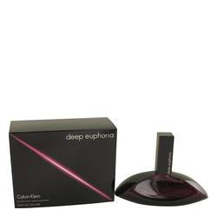

# 

***DEEP EUPHORIA***

## *Description:*

Deep Euphoria by Calvin Klein Perfume. Want your man to be in heaven whenever you’re near? The floral, titillating blend of Deep Euphoria is sure to put him on cloud nine. Introduced by Calvin Klein in 2016, this flattering potpourri is ideal for the bold and sensual woman. Grassy and herbal opening notes of white pepper, mandarin leaf, and cascalone make a tantalizing impression. Notes of black magic rose and white peony dominate the flowery core of this scent. It culminates in an earthy, animalic aroma of musk and patchouli. A whiff of this perfume adds a little spring in your step as well as arouses someone’s passionate side.